For questions on this process, see the Training Resources located here or send an email to Supplierportalsupport@crowley.com.

Entering the Portal
- From the Become a Supplier page, click the Register as a Supplier button.
- Enter your email in the field towards the right of the screen.
- Click the Send Access Code button. This sends a code to the email address entered, which is valid for 15 minutes.

- Retrieve the Access code from your email.
Note: This will come from the email address: efli.fa.incoming@workflow.mail.us6.oraclecloud.com. If you do not see the email in your inbox, check your spam mail folder.

- Enter the code into the prompt box that appears at the right of the screen. Click the Continue button.

Completing the Registration Information
There are seven sections that will need to be completed during the registration process. The title of each section, along with a list of the pages to complete, is located at the right of the screen.

Section 1: Company Details
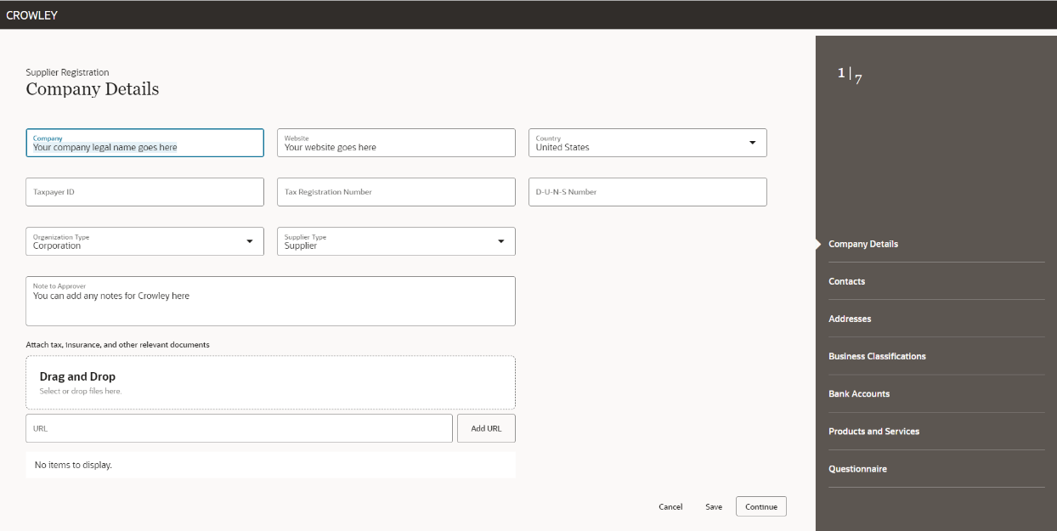

- On the Company Details page, enter the requested information.
Note: If Crowley already has your company’s information in our system (e.g., company name, Taxpayer ID, Tax Registration Number or D-U-N-S number), a notification of a potential duplicate will appear. If this occurs, contact crowleysupplierportalsupport@crowley.com for assistance.

Helpful Links:
- Obtain a free DUNS Number
- Find the NAICS Codes for Your Company
- Your Federal Tax Identification Number (TIN or EIN)

- Enter an optional note to Crowley Procurement in the Notes Box.
Note Regarding the Attachment Section: We ask that you do not use the Attachment Section to upload documents. Instead, you’ll have the opportunity to do so in the Questionnaire Section related to the questions being answered.
- When complete, click the Continue button located at the bottom right of the screen.

Section 2: Contacts

- Enter the information for the contact.
  - For each contact, select the role most appropriate.
  - The contact entered will then receive a link to access the Supplier Portal once the registration request is approved.
- To add an additional contact, use the button located at the bottom of the screen.
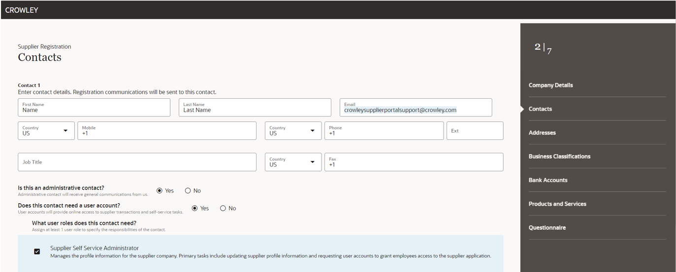
Section 3: Addresses
- Add the address for your company’s headquarters.
- To add additional addresses such as remit to, order from, and pickup, click the button.

Section 4: Business Classifications

- Enter as many business classifications as needed.

Section 5: Bank Accounts
- Enter your company’s banking information, preferably ACH.

Note: This is optional at this point in the process. You can skip this screen and provide the information upon approval.

Section 6: Products and Services
- Click the box next to the NAIC codes applicable for your company.
Note: The search can be used if you are aware of what the code starts with (e.g., NAC 21).
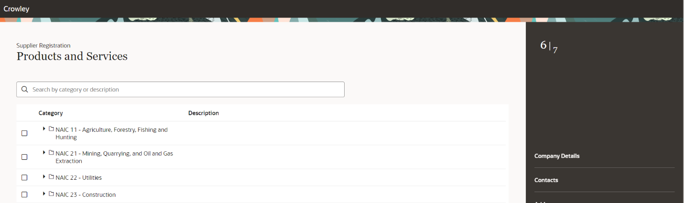

Section 7: Questionnaire
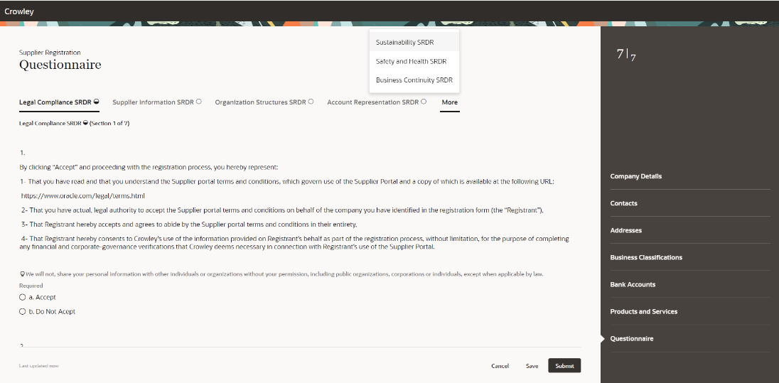
- Respond to the series of questions.

- Once completed, click the Submit button.

This will send the registration request for approval.
Note: Clicking the Save button only saves the application to complete later yet does not route it for approval.

- A confirmation screen with your request number will then appear. You will then be notified within 14 days regarding your approval or if more information is needed.

