Follow these instructions to look up the payment status of your invoices in the supplier portal. All questions should directed to SupplierPortalSupport@crowley.com

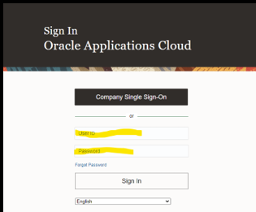
- Log in with your credentials

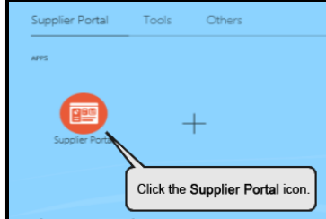
- Access the portal menu to select the desired function.

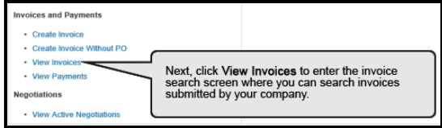
- Select View Invoices

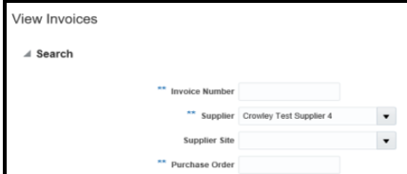
- Ensure your company name is selected in the **Supplier drop down. Note: you can also inquire on a single invoice number or the Crowley purchase order.

- The results of an inquiry using the name of your company will display all invoices associated with your company profile.
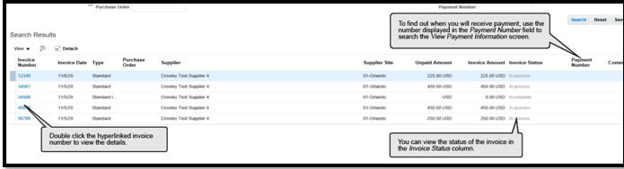
The status of the invoice will appear and the hyperlink will give you access to the invoice data fields.
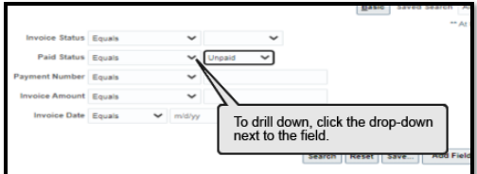
- The View Payments link allows you to search by payment number or status.

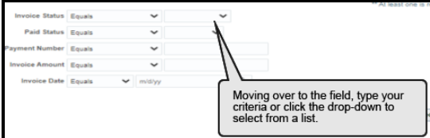
- You can search by invoice status:
In Process, Incomplete, and Complete.

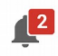
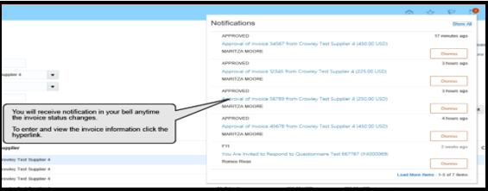
- The bell icon will appear with a number when you have notifications. Click to view the important notifications and respond to Crowley’s requests for action.

